Launching, sustaining, and growing academic detailing careers
The Detailers’ Guide to the Galaxy:
Navigating Challenges and Building Successes for Academic Detailers
NaRCAD Conference
November 13, 2018 at 15h00 Eastern

Facilitators
Zack Dumont  RxFiles Academic Detailing, Regina, SK, Canada &  Saskatchewan Health Authority, Regina, SK, Canada | Brenda Schuster  RxFiles Academic Detailing, Regina, SK, Canada &  Academic Family Medicine Unit,  College of Medicine, Regina, SK, Canada

Purpose of the Workshop
To allow attendees to share their experiences in launching, sustaining, and growing academic detailing careers – their own and others’. The quality of the academic detailing service is delivered through skilled and supported quality academic detailers. This workshop is designed for new and established academic detailers, program directors, and developers.

Relevance
- For those that have never performed the challenging work of an academic detailer, this workshop will provide a heads-up on the work to come.
- For those who have experience with academic detailing from any perspective, this workshop will provide an opportunity to learn from others, and to share your challenges and successes.
- Topic selection, development, implementation, and measurement are challenges all programs will face. Yet, as is the case in any occupation/workplace, there are challenges above and beyond performing our daily duties; specifically, developing a quality detailing team. However, the ways to best navigate those challenges will vary greatly. Given the relative infancy of academic detailing as a “profession,” there is a timely value in sharing ideas and successes.
- Personal resilience and resilience of your team is critical; there are tools to help.

Learning Objectives
- Explore processes shared by different programs for the extrinsic support of academic detailers
- Share processes used by detailers and program leads for the intrinsic support of self
- Explore sample tools for supporting detailers out in the field

Approach to the Workshop
5 minutes | Introductions
5 minutes | Setting the stage: Resilience and Mindset  - Challenges to Resilience and Mindset in the World of Academic Detailing
30 minutes | Breakout Session  - Group 1: Overwhelmed  - Group 2: New Detailer  - Group 3: Experienced Detailer  - Group 4: Program Director  - Group 5: Program Evaluator
30 minutes | Group Discussion – Report back on how you would handle the scenario
15 minutes | Sharing of Our Experiences
5 minutes | Final Thoughts and Wrap Up

Setting the Stage: Resilience and Mindset
Challenges to Resilience and Mindset in the World of Academic Detailing

The world of academic detailing brings great opportunities, interesting, rewarding and challenging work. Building your resilience and having a healthy mindset are important.

Resiliency: is the ability to overcome challenges of all kinds and bounce back stronger, wiser, and more personally powerful.

Mindset: Individuals with a growth mindset believe their talents can be developed through hard work, good strategies, and input from others; these individuals tend to achieve more than those with a fixed mindset (ie, those who believe their talents are innate gifts). When entire teams embrace a growth mindset, individuals report feeling more empowered and committed.
(Source: Dweck C. What Having a “Growth Mindset” Actually Means. Harvard Business Review January 2016. Available from https://hbr.org/2016/01/what-having-a-growth-mindset-actually-means)

Here are seven mindsets that will radically improve your work and your life.

- Self-trust mindset – trust yourself and believe in your capabilities
- Goal-setting mindset – set high goals, reach them
- Patient mindset – sometimes you have to wait for the right thing
- Courageous mindset – courage is like muscle for facing fears (not being unafraid)
- Focused mindset – focus feeds discipline, which turns goals into accomplishments
- Positive mindset – feed yourself reasons why you can and should
- Learning mindset – good things really do come to those who work hard and struggle
(Source: Daskal L. 7 Mindsets That Will Radically Improve Your Life Right Now. Inc. Available from: https://www.inc.com/lolly-daskal/7-mindsets-that-will-radically-improve-your-life-right-now.html)

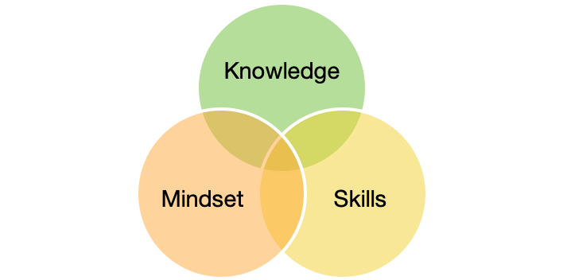
Setting the Stage: Resilience and Mindset

2-Minute Exercise with a Buddy

What are some of the potential challenges to an individual’s resilience and mindset that can be experienced from their work in academic detailing?

Take a perspective that best reflects your current or previous work.
New academic detailer

Experienced academic detailer

Program director

Program evaluator

Breakout Session (30 minutes)

On the following pages there are five different scenarios.

Please select a single scenario.

Review the scenario in your small group and answer the questions that follow (note: each scenario has three similar questions).

Be prepared to report back to the larger group on your discussion.
Group 1: “Feeling overwhelmed”

Shavina is a burgeoning young new practitioner who works as a clinical pharmacist in a primary care clinic. Her time is divided, with 0.7 (out of 1.0) FTE seeing patients and participating as part of the primary care team; the remaining 0.3 FTE is spent as an academic detailer, where she visits practitioners in her local area.

Since she graduated four years ago, and particularly since she finished her residency, Shavina has kept very busy, not only with work, but also she’s involved in two professional advocacy committees, sits on the pharmacy regulatory board, and she’s active in her community as a football coach. She continues to be offered many opportunities from all directions; as her classmate and now colleague says, “everyone wants a chunk of Shavina’s time, energy, and talents”.

For her role as a detailer, she knows she needs to start preparing for the next topic. The training day is only 11 days away, after which she’ll need to start seeing practitioners right away. This means she has several hours of reading to do, appointments to book, and adjusting her clinical schedule to allow her to conduct visits on the AD topic. She’s already tired – though she wouldn’t let it show – and doesn’t know how she’s going to get it all done.

What are the potential challenges to Shavina’s resilience and mindset?

How could Shavina guide herself forward with this challenge?

What could Shavina do outside of work to maintain balance?

Notes:

Group 2: New Detailer, First Topic

Steven is excited about his new position as the academic detailer for his local area. He has always enjoyed and prided himself with his efforts to keep up to date in his practice area of cardiology. Steven has been involved in journal clubs with the cardiac team and feels he has learned a lot about evidence informed decision making.

He knows this job will be challenging and put him in situations he has never been in. He has a real nagging concern about going to speak to physicians about topics he has no or very little clinical experience with. In fact, the current topic on PrEP is something he feels he knows nothing about.

Steven has been finding himself worried about how long it is going to take to learn the new topic, and whether he will be able to get physicians to see him. He is really hoping to be successful but so much seems to be dependent on him. He is accustomed to sharing patient care responsibilities with the team, but now he is feeling out on his own.

What are the potential challenges to Steven’s resilience and mindset?

How could Steven guide himself forward with this challenge?

What could Steven do outside of work to maintain balance?

Notes:

Group 3: New Program Director

Debbie has been the director of a new academic detailing program for the last nine months. She’s been a nurse practitioner for 10 years, and this is her first formal leadership position, which she was encouraged to take by her old professor, Carl. Carl helped establish the program and needed someone he could count on. Debbie was honoured, but felt a bit out of her element. Nevertheless, she trusted Carl and took on the challenge.

She has on her team two full-time staff for medication information and program evaluation, and four contract academic detailers. Debbie just received an email from Carl to let her know that the granting body has requested the first annual report for evaluation prior to the end of the fiscal year. He has no additional information or guidance, but suggested she review the initial grant application, which “would surely have something that could be recycled and updated”.

What are the potential challenges to Debbie’s resilience and mindset?

How could Debbie guide herself forward with this challenge?

What could Debbie do outside of work to maintain balance?

Notes:

Group 4: Experienced Detailer

Kevin has been providing academic detailing services in his local area now for six years. It has been a challenge but he feels proud of how he has established relationships with local prescribers and with the service he has provided. Kevin knows he has a great job he enjoys, but lately has not been as energetic in his work.

The current detailing visits will focus on tapering opioids. On Kevin's last visit he was discussing treatment of chronic non-cancer pain and physicians always spoke about their most difficult patients being the ones on high doses of opioids. He remembers several physicians stating that these patients are what make a day really challenging. He knows that the evidence for tapering in this area is weak. Steven really is not looking forward to hearing physicians bring up barriers to the real world challenges they have with their patients.

Kevin is also anticipating that some physicians might not be interested to discuss this topic.

What are the potential challenges to Kevin’s resilience and mindset?

How could Kevin guide himself forward with this challenge?

What could Kevin do outside of work to maintain balance?

Notes:

Group 5: Program Evaluator

Michael is a recent graduate from a Master’s in Public Health program, and his first gig is with the local health system’s academic detailing program. Throughout all of his education he had never heard of academic detailing, but was excited by the prospect of conducting real-world data capture and analysis. Further, his thesis was on the effect of a knowledge translation effort to increase vaccination rates, so he was comfortable with the potential data sources and was confident he knew which outcomes might be of interest.

The director of his program just asked him to develop an evaluation plan for the latest topic – one which would likely determine whether or not the program’s grant would be extended. Though initially excited, his director informed him that with the topic of behavioural and psychological symptoms of dementia, they are interested in reduction of the prescribing of atypical antipsychotics, but that there are several possible side effects, such as increases in benzodiazepines and other sedatives. Further complicating matters, the detailers have been seeing practitioners from several different long-term care facilities, each which uses different medication suppliers.

What are the potential challenges to Michael’s resilience and mindset?

How could Michael guide himself forward with this challenge?

What could Michael do outside of work to maintain balance?

Notes:

Group Discussion (30 minutes)

Each group shares highlights of their responses to the scenario.

Consider using the rest of this page to capture:
- Tips and tricks that you shared or heard from your colleagues
- Your own self-reflection from the discussions
- Contact information for people that you’ve met during the workshop that you can follow up with
- Resources, websites, etc that might offer additional support

Our Experience (15 minutes)

1. Webinar: Building Resiliency as an Academic Detailer – Taking Care of Yourself

Pre-Webinar Exercise (distributed two to four weeks in advance, reminder one week before)
- Wellness Self-Assessment exercise (see Resources for link)
- Mind mapping exercise
- Resiliency self-reflection questions

Webinar
- Wellness Self-Assessment – 5 to 10minutes
  - Brief overview, not seeking anyone specific sharing, just acknowledge of how this creates self-awareness
    - Review document
      - Wellness definition
      - Domain of wellness
  - Reflection/discussion of how wellness can vary, need for awareness of change
  - Take Action Plan: what are your feelings on SMART Goals – good for others? good for you?

- Mind Mapping – 15 minutes
  - Brief overview, attendees do a mind map prior to session
    - Review Mind Map concept
      - At the centre of the mind map is you as a happy, healthy, resilient academic detailer (you can draw yourself, or just put your name). Off the centre are the branches (as many as you want), each representing a single word that is important to you to be resilient. Off that word you can have sub-branches to further expand on ideas/concepts or actions that support that word.
  - Facilitate a discussion of attendees regarding experience with this exercise

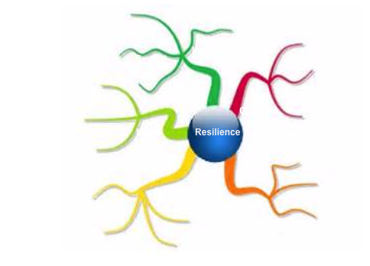
- Resiliency Self Reflection – 30 minutes
  - What are your own thoughts on the need to be a resilient academic detailer?
  - What might you do to build your resilience? What opportunities or challenges have you experienced that have built or challenged your resiliency? Success or challenges?

2. Additional Suggestions to Build Support for the Individual
- Training

- Mentoring

- One-on-one follow-up

- Open-door policy

- Debriefing

3. Additional Suggestions to Build Support for the Team
- Pre-upskilling day webinars

- Upskilling day ice breakers (eg, “two truths and a lie”, “best story ever”)

- Incorporating games (eg, Jeopardy)

- Team building outside of work (dinners, parties, board games, Facebook Group private page, etc)

Final Thoughts and Wrap Up (5 minutes)

Self-Reflection:
What are your own thoughts on the need to be a resilient academic detailer?

What might you do to build your resilience?

What might you do to develop your growth mindset?

What is the one thing that you might implement as a result of this workshop:

Resources
- American Psychological Association http://www.apa.org/helpcenter/road-resilience.aspx
- Princeton University U Matter: Actively Caring for Yourself and others https://umatter.princeton.edu
- Wellness Self-Assessment https://umatter.princeton.edu/sites/umatter/files/media/princeton-umatter-wellness-self-assessment.pdf
- Government of Canada. Road to Mental Readiness: Mental Health Continuum Model. Retrieved from: http://www.forces.gc.ca/en/caf-community-health-services-r2mr/index.page
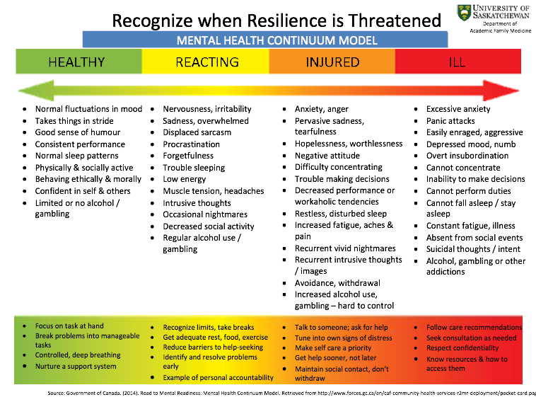

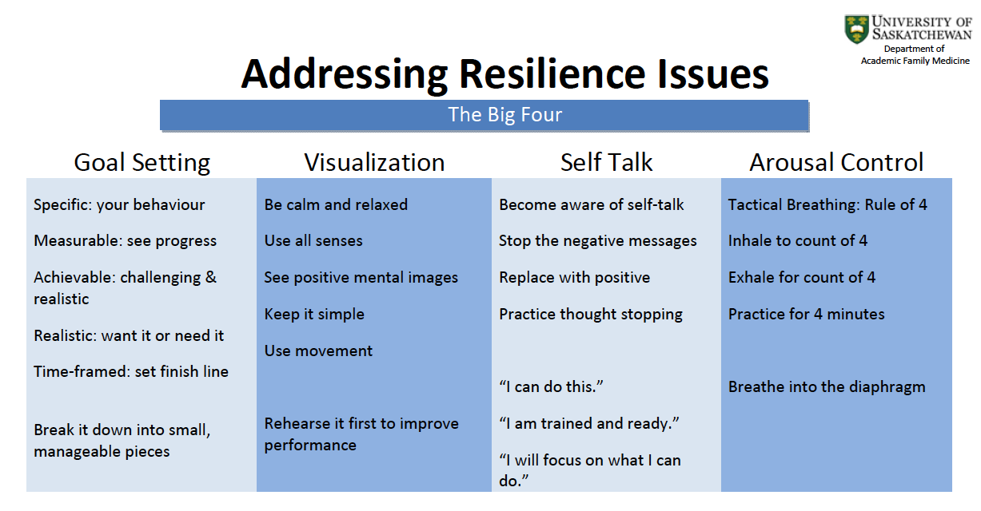
Tips to Build Your Resilience as an Academic Detailer

- Build positive relationships for the long-term.

- Believe you have an important service.

- Envision what your service could be in the best of all possible worlds, then set achievable goals for building and growing your service and developing your skills.

- Accept that some visits will be amazing connections and some less so.

- Appreciate differences in perspective, and put them into perspective.

- Build on your strengths and the uniqueness of your service.

- Pay close attention to your own needs and make time to attend to them.

- Spend time reflecting on, and growing from, your experiences as a detailer.

- Pay attention to your feelings, knowing they are sometimes present for a reason.

- Forgive yourself when a visit is not quite what you had hoped for.

- Develop relationships with your academic detailing colleagues. We have so much to learn and share with one another in our unique work.

- Embrace challenges! You will grow and learn.

- Learn not only from your mistakes, but also the mistakes of others.

- Never give up. A closed door today could be an open door next week, next month or a decade from now.

- Be ok with, and learn from difficult situations. Our work is unpredictable at times, and you need to go with the flow.

- Be hopefully optimistic.

- Challenge those negative thoughts.

- Learn to problem solve.

- Remember that the physician you are visiting may be having a day that is challenging their own resiliency.

- Plan your work, work your plan.

Reference: 20 Tips To Build Your Resilience. Desborough and Hazlemere Surgeries May 2017. Available from: https://desborough.gpsurgery.net/20-tips-build-resilience/

